Deafblind Scotland
February 2026 Newsletter
February is a time for staying connected and supporting one another. Below, you’ll find information about our current activities, events, and news updates.

Activities in-person at DBS centre, Kirkintilloch

Every Monday 10am – 12pm
Scrabble and Chess

Monday 02 March – Monday 30 March
Recyke-A-Bike
Take part in a side-by-side bike ride at DbS Centre. Each ride will last 30 minutes along local paths and will be followed by tea and coffee. Time slots will be allocated for each participant.

Monday 30 March, 13 April – 27 April
2.45pm – 4.15pm
Taiko Drumming – join Kirsty for taiko drumming, beginners welcome.

BSL CAFÉ
Monday 02 February – Monday 23 March
1pm - 2.30pm
Come along on Monday afternoons to meet with other deafblind people, learn and practice Deafblind Manual and/or British Sign Language.
You’ll make friends, get to learn and practice new skills that will help you communicate now and in the future. Beginners are very welcome.
The upcoming sessions will also include practising signing some songs in BSL as part of a deafblind choir.
We can provide a Guide/Communicator if needed.

Every Thursday 10.30am – 12pm
Walking Group

On-Line Zoom Classes

Tuesday 24 February 10am – 11am
My Way Project
Get involved in our new project to design a tool which will support deafblind people in planning their lives, setting goals and tracking progress toward better wellbeing.
Zoom Meeting ID: 882 2972 4791
Passcode: DBS

Thursday morning, 11am – 12pm – Quiz
Join DBS Quiz master Ian for our weekly quiz and put your knowledge to the test! Come join us for some fun and learning!
Zoom Meeting ID: 876 4249 8273
Passcode: DBS

Friday afternoon, 2pm – 3pm - Bingo
Dabbers at the ready! Join Bingo King Ian for fun and laughter at our weekly bingo session.
Zoom Meeting ID: 912 1837 5953
Passcode: DBS

One-Off Events

SAGoD
The next SAGoD meeting is Thursday 19 March, from 10.30am to 3pm.
Part of the meeting will include a consultation from the Scottish Government. They want to hear about the experiences of deafblind people, and what you share will help shape their work in Health and Social Care.
We would be very happy to see you there.
Lunch will be provided, and there will be time to chat with friends, both old and new.
Please tick the reply sheet if you would like to come and let us know if you need a guide/communicator.

Fire Station Visit – Date to be confirmed
Visit to Cambuslang Fire Station for an engaging and practical home-safety session. You will get to enjoy a live demonstration around a model home, learning simple, effective ways to keep households safer and prevent common hazards.
Spaces will be limited so please register interest and we will get back to you to confirm the details.

Deafblind Scotland Counselling Services
We currently have funding to offer one-to-one counselling with a BACP-accredited counsellor to members living in North Lanarkshire and Fife. Support is available by phone, FaceTime or online, whichever works best for you. For more information, please contact Julie Ritchie by email development@dbscotland.org.uk or phone 0141 777 6111.

Scottish Election
The 2026 Scottish Parliament election is being held on Thursday 07 May 2026 and will elect 129 members to the Scottish Parliament. If you plan to use a Guide Communicator and need them to come with you into the voting booth, please let us know. We will contact your polling station so they are aware and can support this.

Member News
We’re delighted to share DbS member Andrew Pettigrew has had his poem, A Pocket of Air published. We hope you enjoy the beautiful and inspiring words.

What is love?
To me, it’s the hand that touches mine,
that traces invisible letters,
etching light into my palm—
a language of silence, without sight,
creating a pocket of air
in a burning world
that shields me from its noise
and flame and rage.

In the inferno your hand is all I have—
light for my lightless eyes, guiding me
through smoke and ash and dizzying heat,
constant even as the ground gives way
and others abandon me for who I am.
You let me breathe and smile and be,
your signing the reason I don’t need to see,
your fingers a cradle, your touch a balm,
and that’s
all the love I need.

More Member News
Some exciting news from DbS member Lacey Gladwin who has just published their second book! Turn About is ready to buy on Amazon or EBook https://amzn.eu/d/02mKlt1X
A white gelding admires his chestnut-red friend and wishes he could look just like him. Feeling sad that he can’t be red, he stumbles into the mud and has an idea.

Usher Syndrome Helpline
Do you have Usher Syndrome, or care for someone who does? The Usher Syndrome Helpline will answer questions, offer support, or simply listen. The free phoneline is open Monday to Friday from 10am – 1pm (not including bank holidays) and is available in English and British Sign Language. You can book a BSL/English interpreter through Contact Scotland BSL. The helpline is run by Deafblind UK and Deafblind Scotland, with support from partner organisations and supports people of all ages and all types of Usher Syndrome.
- Phone: 01733 973 500
- Text: 07800 008 088
- Email: usherhelpline@deafblind.org.uk
- Text relay: 18001 then 01733 973 500
- Scotland: Book a BSL/English interpreter via Contact Scotland BSL

External Events
Protactile Communication Workshop
PT Celebrate is taking place on Sunday 19 April, 6–9pm in Glasgow, venue to be confirmed. Everyone is welcome, and food and refreshments will be provided.
If you would like more information and to register interest in attending, please email:
protactilescotland@gmail.com

RNIB Glasgow Museum Visits
March 4, Glasgow Museums Resource Centre
April 1, Kelvingrove
RNIB are running Glasgow Museum visits which will include object handling sessions and audio described tours with museum staff. Visits are from 10am - 12pm with some sighted guide support available. To book, contact Conor Joseph phone: 07871 736351, or email Conor.Joseph@rnib.org.uk

Mental Health and Wellbeing
Each month we’ll share a few practical ideas to help you build a strong focus on your mental health and overall wellbeing.
February - Strengthen Social and Emotional Health
Activities
- Join in a Deafblind Scotland activity.
- Try a calming activity like hand massage or warm-touch relaxation.
Communication Strategies
- Practise expressing emotional needs clearly using your preferred method.
- Use tactile cues or pre-agreed signals with close contacts.
- Explore accessible mental-health support options if needed.

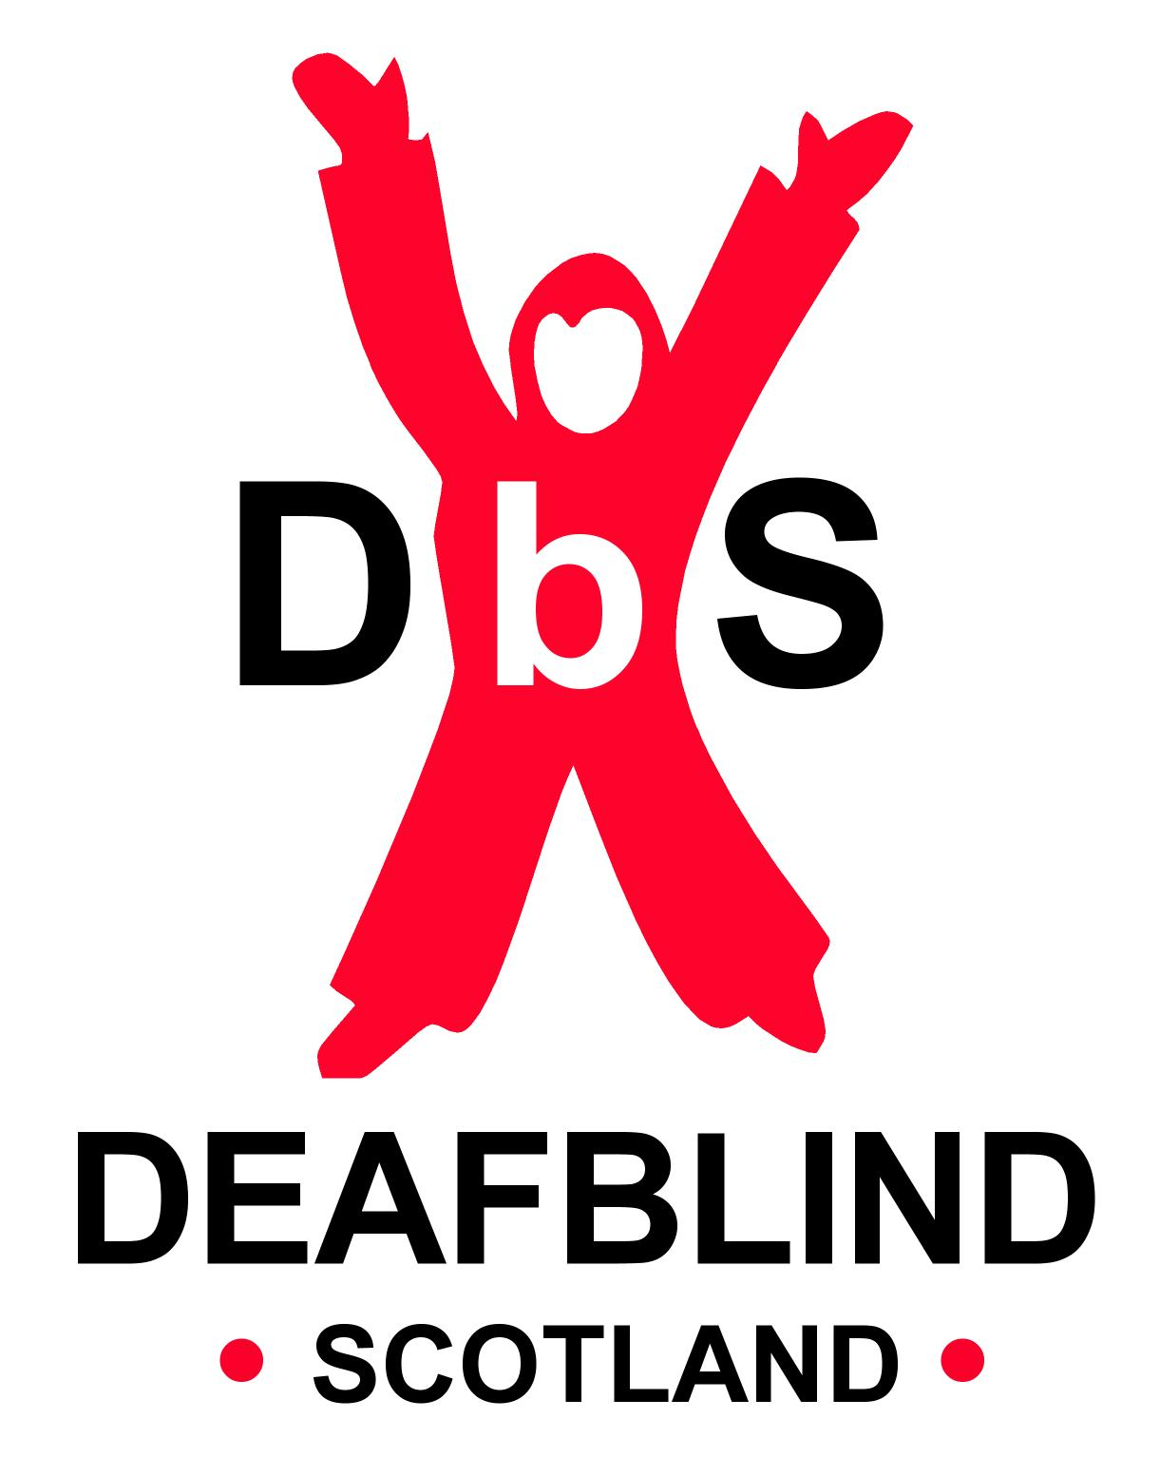

Scottish Charity SC031167

