Deafblind Scotland
January 2026 Newsletter
Happy new year to all our members. We hope you’ve had a lovely time over the festive season, and we look forward to welcoming you to an exciting year of activities and events.
Activities in-person at DBS centre, Kirkintilloch
Every Monday 10am – 12pm
Scrabble and Chess

BSL CAFÉ
Monday 02 February – Monday 23 March
1pm - 2.30pm
Come along on Monday afternoons to meet with other deafblind people, learn and practice Deafblind Manual and/or British Sign Language.
You’ll make friends, get to learn and practice new skills that will help you communicate now and in the future. Beginners are very welcome.
The upcoming sessions will also include practicing signing some songs in BSL as part of a deafblind choir.
We can provide a Guide/Communicator if needed.
Every Thursday 10.30am – 12pm
Walking Group

On-Line Zoom Classes

Tuesday 24 February 10am – 11am
My Way Project
Get involved in our new project to design a tool which will support deafblind people in planning their lives, setting goals and tracking progress toward better wellbeing.
Zoom Meeting ID: 882 2972 4791
Passcode: DBS

Thursday morning, 11am – 12pm – Quiz
Join DBS Quiz master Ian for our weekly quiz and put your knowledge to the test! Come join us for some fun and learning!
Zoom Meeting ID: 876 4249 8273
Passcode: DBS

Friday afternoon, 2pm – 3pm - Bingo
Dabbers at the ready! Join Bingo King Ian for fun and laughter at our weekly bingo session.
Zoom Meeting ID: 912 1837 5953
Passcode: DBS

Deafblind Scotland Counselling Services
We’re delighted to share we have funding to offer one-to-one counselling with a BACP-accredited counsellor to our members living in North Lanarkshire and Fife. Support is available by phone, FaceTime or online, whichever works best for you.
If you would find this helpful or want more information, please contact Julie Ritchie by email development@dbscotland.org.uk or phone 0141 777 6111.

Mental Health and Wellbeing
Each month we’ll share a few practical ideas to help you build a strong focus on your mental health and overall wellbeing.
January — Build a Strong Start
Activities
- Create a basic weekly routine using tactile or large-print planners.
- Add gentle movement such as chair exercises, stretching, or short indoor walks.
- Check that mobility aids are safe and working properly.

Communication
- Let friends and family know your preferred way to communicate.
- Practise tactile signing or braille for a few minutes each day.
- Set up accessible tools like vibrating alerts or speech-to-text apps.

External Events and Activities
Forth Valley Sensory Centre are planning to set up an Electoral Voting Focus Group. Dates are still to be confirmed, but the aim is to hold the first session toward the end of January, with an option to take part in filming at a later stage. The purpose of the group is to highlight the challenges people face when voting and explore possible solutions, helping polling stations become better informed and better prepared.
Participants will be offered a £20 gift voucher as a token of thanks.
Please contact Julie by phone 0141 777 6111 or email development@dbscotland.org.uk for more information.

RNIB Glasgow Museum Visits
February 4, Riverside Museum
March 4, Glasgow Museums Resource Centre
April 1, Kelvingrove
May 6, Kelvin Hall
June 3, Riverside Museum
RNIB will be running Glasgow Museum visits throughout this year. Many of these tours will include object handling sessions and audio described tours with museum staff. All visits will run on Wednesdays from 10am to 12pm with some sighted guide support available. Spaces are limited, please contact Conor Joseph by phone: 07871 736351, or email Conor.Joseph@rnib.org.uk

Sight Village Glasgow
Sight Village Glasgow takes place on Wednesday 18 March from 9am to 3pm, and entry is free. The event will be held at the Glasgow Science Centre, 50 Pacific Quay, Glasgow G51 1EA, where visitors can explore and try out the latest assistive technology, products, and support services.
For more information or to book tickets, visit www.qacsightvillage.org.uk or call 0121 803 5313.
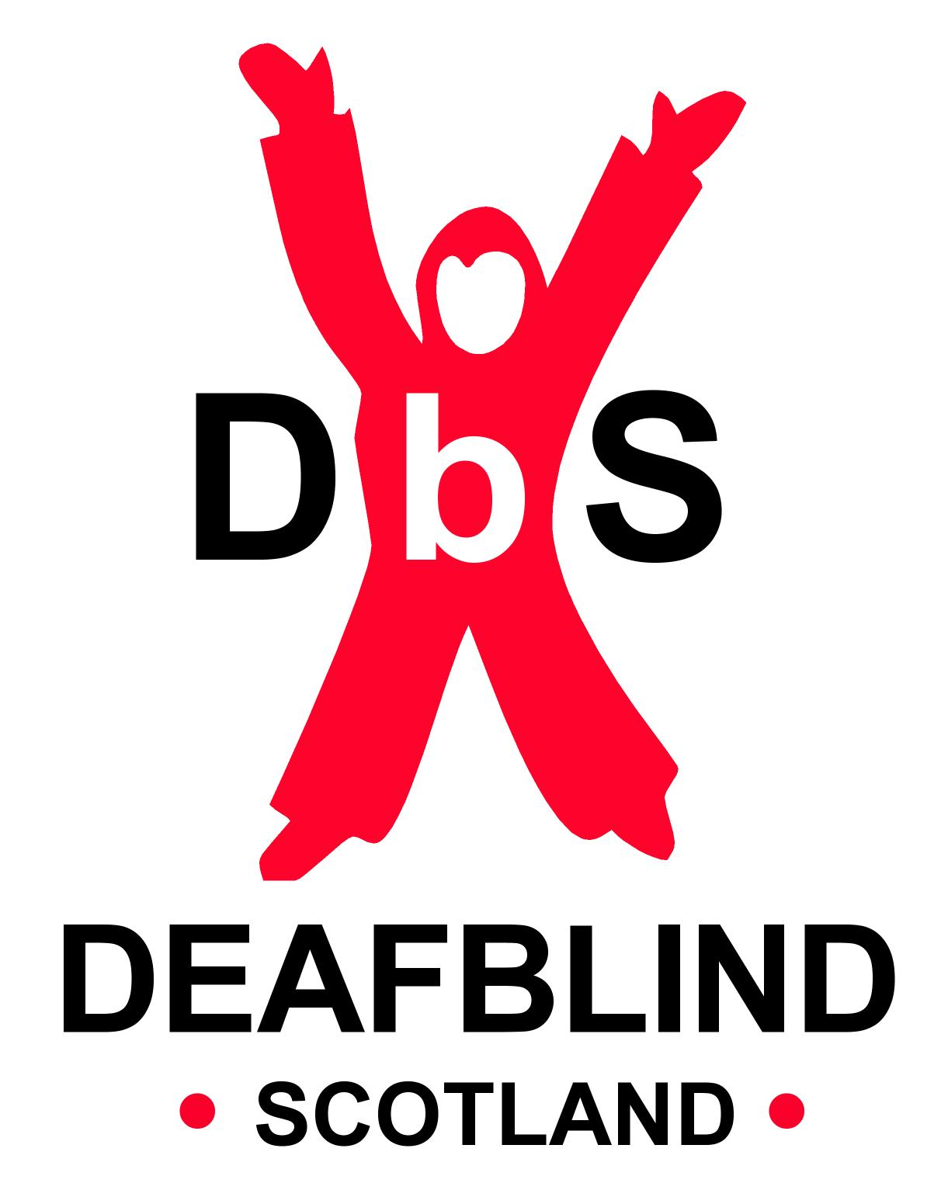

Scottish Charity SC031167

