Deafblind Scotland
October 2025 Newsletter
Activities in-person at DBS centre, Kirkintilloch

Every Monday 10am – 12pm
Scrabble and Chess

Tuesday 07 October, 21 October,
04, 18 November 1pm – 3pm
Craft Class with Andrea from Sight Scotland.

Every Thursday 10.30am – 12pm
Walking Group

Friday 03 October 10am - 11.30 am
Singing Class

On-Line Zoom Classes

Thursday morning – Quiz
Every Thursday 11am – 12pm
Join DBS Quiz master Ian for our weekly quiz and put your knowledge to the test! Come join us for some fun and learning!
Zoom Meeting ID: 876 4249 8273
Passcode: DBS

Friday afternoon - Bingo
Every Friday 2pm – 3pm
Dabbers at the ready! Join Bingo King Ian for fun and laughter at our weekly bingo session.
Zoom Meeting ID: 912 1837 5953
Passcode: DBS

One-Off Events

Tuesday 30 September – Bushcraft
1030am – 1pm
Join us around the campfire for another great bushcraft session at Pollok Park.

Tuesday 28 October – Falls Prevention Talk
2pm – 3.30pm
East Dunbartonshire HSCP are hosting a falls prevention workshop. We'll discuss the impact of falls, ways to stay active, and introduce helpful resources and safety tips.

Tuesday 11 November – First Aid Talk
1030am - 12pm
We’re delighted to welcome St Andrew’s First Aid for a special talk, where they’ll be sharing essential life-saving skills and insights into their incredible work.
Three Bridges Cruise - open to carers and deafblind people in Greater Glasgow and Fife.
Are you a carer or family/friend of a deafblind person? This trip gives carers a fun relaxing outing, and you can bring a deafblind person with you. Take in the spectacular Three Bridges, the beautiful panoramas of the Edinburgh skyline, Inchcolm Island with its medieval abbey, and look out for the seals and marine wildlife. Relax and listen to the guided commentary.
Date: 27 October 2025
Time: Set sail at 11am, cruise lasts 1.5 hours
Venue: Hawes Pier, South Queensferry
Followed by lunch at Hawes Inn at 12.45pm
Contact Ruth Hart information@dbscotland.org.uk 0141 777 6111

External News

All Abilities Event - Disability is not Inability
Join for an empowering afternoon celebrating inclusion, support, and accessible sports!
Friday, 10 October
12:00 PM – 4:00 PM
Easterhouse Sports Centre, 12 Auchinlea Road, Glasgow, G34 9HQ
Discover local resources, try inclusive activities, and connect with organisations making a difference.
North Lanarkshire Activities
RNIB Support group runs in Market Square Cafe in Airdrie, on the 2nd and 4th Tuesday of each month from 10 - 11.15am. We have a cuppa and chat; the group are a happy bunch and welcome new members.
Airdrie & Coatbridge Visually Impaired Bowling Club ACVIBC, welcome anyone who would like to try bowls or get back to lawn bowls. We meet in Coatbridge Indoor Bowling Club from September - March and in April - August we play outdoors at Airdrie Bowling Club. We bowl weekly on Fridays 10am – 12pm. For further information or you want to chat about either group please contact DbS member Sharon Moncrieff by email topcat26964@gmail.com or text or WhatsApp 07906339188.

Free Human Rights Webinars in Scotland
The Scottish Human Rights Commission is offering free webinars on using the UN human rights system to protect rights in Scotland. Topics include housing, discrimination, privacy, and family life. BSL interpretation is available at all events. Learn how to take action locally using international human rights laws. For more information email, events@scottishhumanrights.com or contact via Contact Scotland BSL.
www.scottishhumanrights.com/news
Member News

DbS member Avril has sent in a lovely poem she wrote to share with fellow members - Keil’s Den.

My friend and I went for a woodland walk in Keil’s Den,
We met a couple Jack and Jen,
They have been on holiday in the Fens,
We passed a farmyard with clucking hens,
As we overtook a man Len,
Who had two dogs Bonnie and Ben,
Walking on the Flat Ground,
We found a foreign coin, a yen,
Seeing in the distance we got a fiew of Largo Law through the camera lens,
Climbing up a steep hill we met two men Ian and Ken,
Keil’s Den seemed more like a glen,
At the end of the walk, we passed an old man with two bulldogs Bron and Bren,
This circular walk marked nine out of ten,
Maybe next time we will walk Keil’s den back to front, but when?
Don’t know if the weather will be good from September onwards, by then?
That was the end of the poem written by pen!

Also more exciting news! DbS member Lacey, is now a published author. The book is available now on Amazon - check it out here, https://amzn.eu/d/gTMBWXH

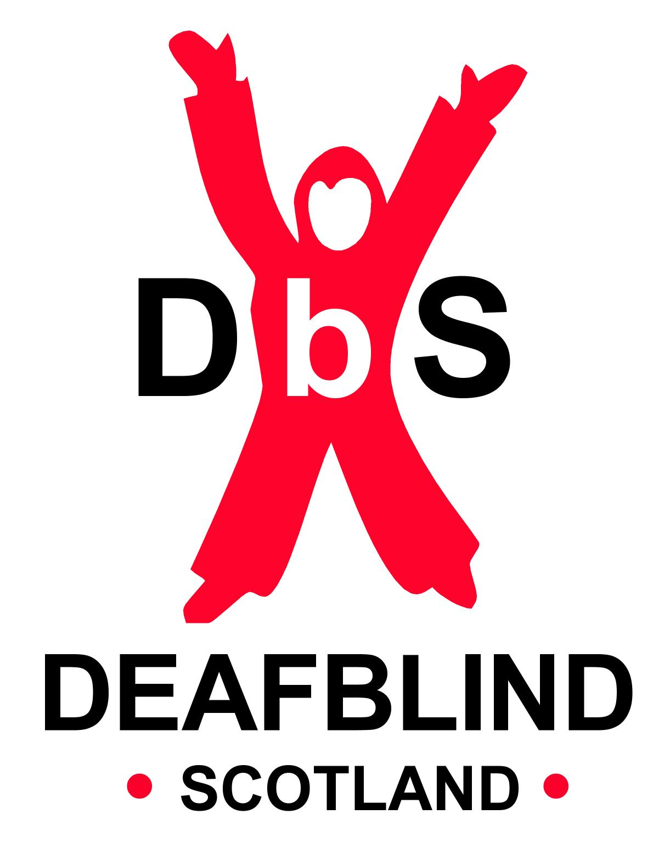

Scottish Charity SC031167

