Deafblind Scotland
December 2025 Newsletter
Wishing a very Merry Christmas to those who celebrate, and warm seasonal greetings to everyone. May this time bring joy, peace and special moments with those you love.
We’ve included details of our final activities for 2025, along with two DbS 2026 wall calendars to help you plan your diary for the coming year.
Activities in-person at DBS centre, Kirkintilloch
Every Monday 10am – 12pm
Scrabble and Chess

Tuesday 16 November 10.30am - 12pm
My Way Project – Get involved in our new project to design a tool which will support deafblind people in planning their lives, setting goals and tracking progress toward better wellbeing.

Every Thursday 10.30am – 12pm
Walking Group

On-Line Zoom Classes

Thursday morning, 11am – 12pm – Quiz
Join DBS Quiz master Ian for our weekly quiz and put your knowledge to the test! Come join us for some fun and learning!
Zoom Meeting ID: 876 4249 8273
Passcode: DBS

Friday afternoon, 2pm – 3pm - Bingo
Dabbers at the ready! Join Bingo King Ian for fun and laughter at our weekly bingo session.
Zoom Meeting ID: 912 1837 5953
Passcode: DBS

Deafblind Scotland Counselling Services
We’re delighted to share we have funding to offer one-to-one counselling with a BACP-accredited counsellor to our members living in North Lanarkshire and Fife. Support is available by phone, FaceTime or online, whichever works best for you.
If you would find this helpful or want more information, please contact Julie Ritchie by email development@dbscotland.org.uk or phone 0141 777 6111.

Document Magnifier Donation
One of our members has kindly gifted a Humanware Prodigy document magnifier, and we’d love for it to go to someone who can make good use of it. If you’d like to have it, please contact markjfiddy@outlook.com

External Events and Activities

Social Bite Christmas Lunch
Social Bite are running free festive meals for all on Christmas Eve and Christmas Day from 12pm-4pm. They will serve a two-course meal, with a veggie option and presents. Eat in or take away. Booking is required and can be made in person by visiting the coffee shop during December. The address is, 10 Sauchiehall Street, Glasgow, G2 3GF.

North Lanarkshire Activities
RNIB Support group runs in Market Square Cafe in Airdrie, on the 2nd and 4th Tuesday of each month from 1000 - 1115am. The group are happy to welcome new members for a cuppa and chat.

Airdrie & Coatbridge Visually Impaired Bowling Club ACVIBC, welcome anyone who would like to try bowls or get back to lawn bowls. They meet in Coatbridge Indoor Bowling Club from September - March and in April - August play outdoors at Airdrie Bowling Club. Bowling is weekly on Fridays 10am – 12pm. For further information or if you want to chat about either group please contact DbS member Sharon Moncrieff by email topcat26964@gmail.com or text or WhatsApp 07906339188.

External Research Opportunities

Glasgow Centre for Inclusive Living
Voices At Work is a project led by people with long term conditions. It aims to identify what helps - and what hinders - staying in work and to create practical solutions for fairer, more inclusive workplaces. The project will develop a toolkit to improve retention and opportunities.
It is currently recruiting people to join either the steering group or the consultation group. People must live in Glasgow City Council area, be in paid work or have worked within the last five years.
For more information about the project, or to take part, please phone 0141 550 4455 or email Stacey.Highfield@gcil.org.uk

Take part in a study to improve knowledge of Charles Bonnet Syndrome
Cardiff University is running an online study on visual imagination in people with sight impairment, including those who may experience visual hallucinations (Charles Bonnet Syndrome). Adults with sight loss are invited to take part in an anonymous, 60-minute questionnaire about your sight condition, any hallucination experiences and your ability to imagine visual scenes.
For more information and to take part, please visit https://tinyurl.com/sight-impairment-study

Take part in a research study to help design a translation app between BSL and spoken English
The University of the West of Scotland (UWS) in collaboration with Gestura Technologies Ltd are conducting a study to shape a new British Sign Language (BSL) translation app. Deaf BSL users can share communication experiences in a 60–90 minute interview, helping design inclusive technology. Participants receive a £30 Amazon voucher.
For more information on the project, please contact Soheeb.Khan@uws.ac.uk

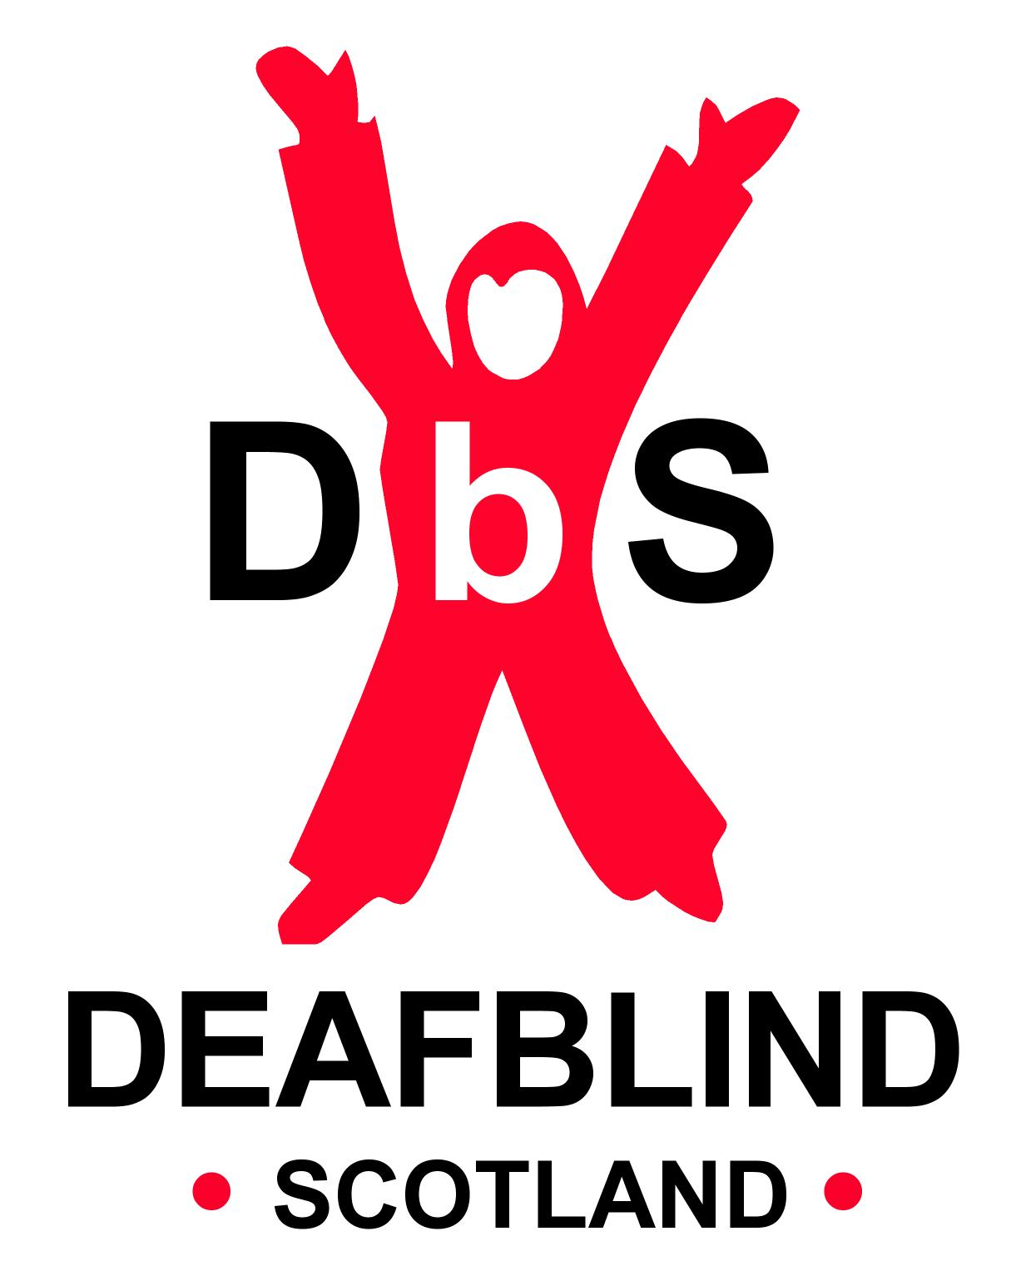

Scottish Charity SC031167

